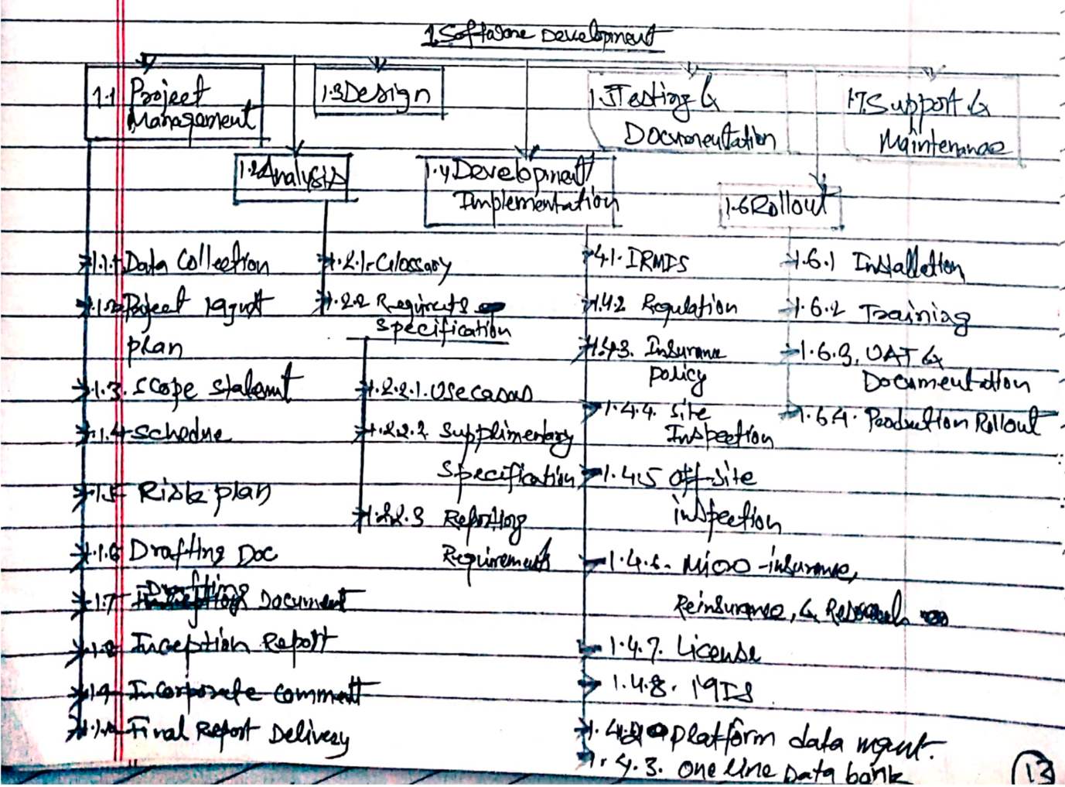

Sample WBS structure keeping project level at the top.